

**The Lab Insider**

DEPARTMENT OF PATHOLOGY AND CLINICAL LABORATORY NEWSLETTER Summer 2021

MESSAGE FROM OUR LEADERSHIP:

F

or the Department of Pathology and Clinical Laboratory at Medical Center, 2020-2021 was a year of unprecedented activity, reorganization, and growth. With the introduction of new technology, a new testing menu and implementation of important patient safety, resource utilization and enhanced value measures, we have continued to provide outstanding service to Medical Center physicians and patients throughout the pandemic.

Our department, which is accredited by the Joint Commission, offers numerous outreach consultation services for both anatomic and clinical pathology through multiple divisions, including:

* Division of Transfusion Medicine (Blood Bank and Blood Donor Center)
* Division of Microbiology, which includes Molecular Microbiology
* Division of Core Laboratory (Chemistry, Hematology, Urinalysis, Coagulation, Drug Screening)
* Division of Point of Care Testing
* Division of Pathology (Histology and Anatomic Pathology)
* Department of Laboratory Support Services, which includes our inpatient and outpatient phlebotomy team, Client Services and Outreach

2020 highlighted the dedication and efforts of our multiple laboratory divisions. The Core Laboratory and Microbiology divisions were at the heart of these efforts, with multiple tests introduced specifically in response to COVID-19, including serology and rapid molecular testing. Throughout the pandemic, we were able to maintain full laboratory operations while adhering to COVID-19 safety precautions.

Our goals for the remainder of 2021 and beyond include expanding outreach by providing new tests and services, mainly in molecular microbiology and anatomic and clinical pathology, while maintaining systems that improve customer service, quality of care delivery and patient safety.

Through this newsletter, our hope is to keep you apprised of changes and improvements relevant to your clinical practice, so you can provide the most up-to-date information to

your patients.

Sincerely,

*Director, Laboratory & Clinical Laboratory Medical*

**2020-2021** BY THE NUMBERS

Open 24/7, 365 days/year • 176 employees • 3.8 million tests annually • 13,000 products transfused

* PHLEBOTOMY DRAWS PERFORMED: 153,998 inpatient • 50,000 outreach • TESTS PERFORMED: 83,325 histopathology • 8,000 cytology • 75,000 microbiology • 265,000 chemistry • 95,000 hematology • 13,647 non-COVID PCR • 35,000 COVID-19 • 700 point-of-care glucose tests daily

# COVID-19 SEROLOGY TESTING

D

ue to the complexity of antibody testing for different targets of SARS-CoV-2 with the prevalence

of vaccination and the challenges associated with interpreting test results, an order for SARS-CoV-2 serology will trigger *three separate tests:* IgG to spike protein (IgGsp), IgM to spike protein (IgMsp) and IgG to nucleocapsid protein (IgGnc).

The U.S. Centers for Disease Control and Prevention (CDC) does not recommend serological testing to assess COVID-19-driven immunity following vaccination or to assess the need for vaccination in an unvaccinated person at this time.* However, if a provider chooses to order serology tests for a patient after vaccination, a panel of all three tests will provide a more complete clinical picture of each patient’s status:



TEST WHAT THE TEST SHOWS

IgGsp Vaccination and previous exposure/infection IgMsp Vaccination and previous exposure/infection

IgGnc Previous exposure/infection/not present in current vaccines

Please see Interim Guidelines for COVID-19 Antibody Testing in Clinical and Public Health Settings at CDC.gov for a detailed discussion and review of recommendations for COVID-19 antibody testing.

*\*Narasimhan M, Mahimainathan L, Araj E, Clark AE, et. Al. 2021. Clinical evaluation of the Abbott Alinity*

*SARS-CoV-2 spike-specific quantitative IgG and IgM assays among infected, recovered, and vaccinated groups. J Clin Microbiol 59:e00388-21. https://doi.org/10.1128/JCM.00388-21*

Technology UPDATE

*Memorial laboratory team poses with the new Alinity technology. Photo/Medical Center*

On June 22, 2021, Medical Center became the first Alinity Hospital-based

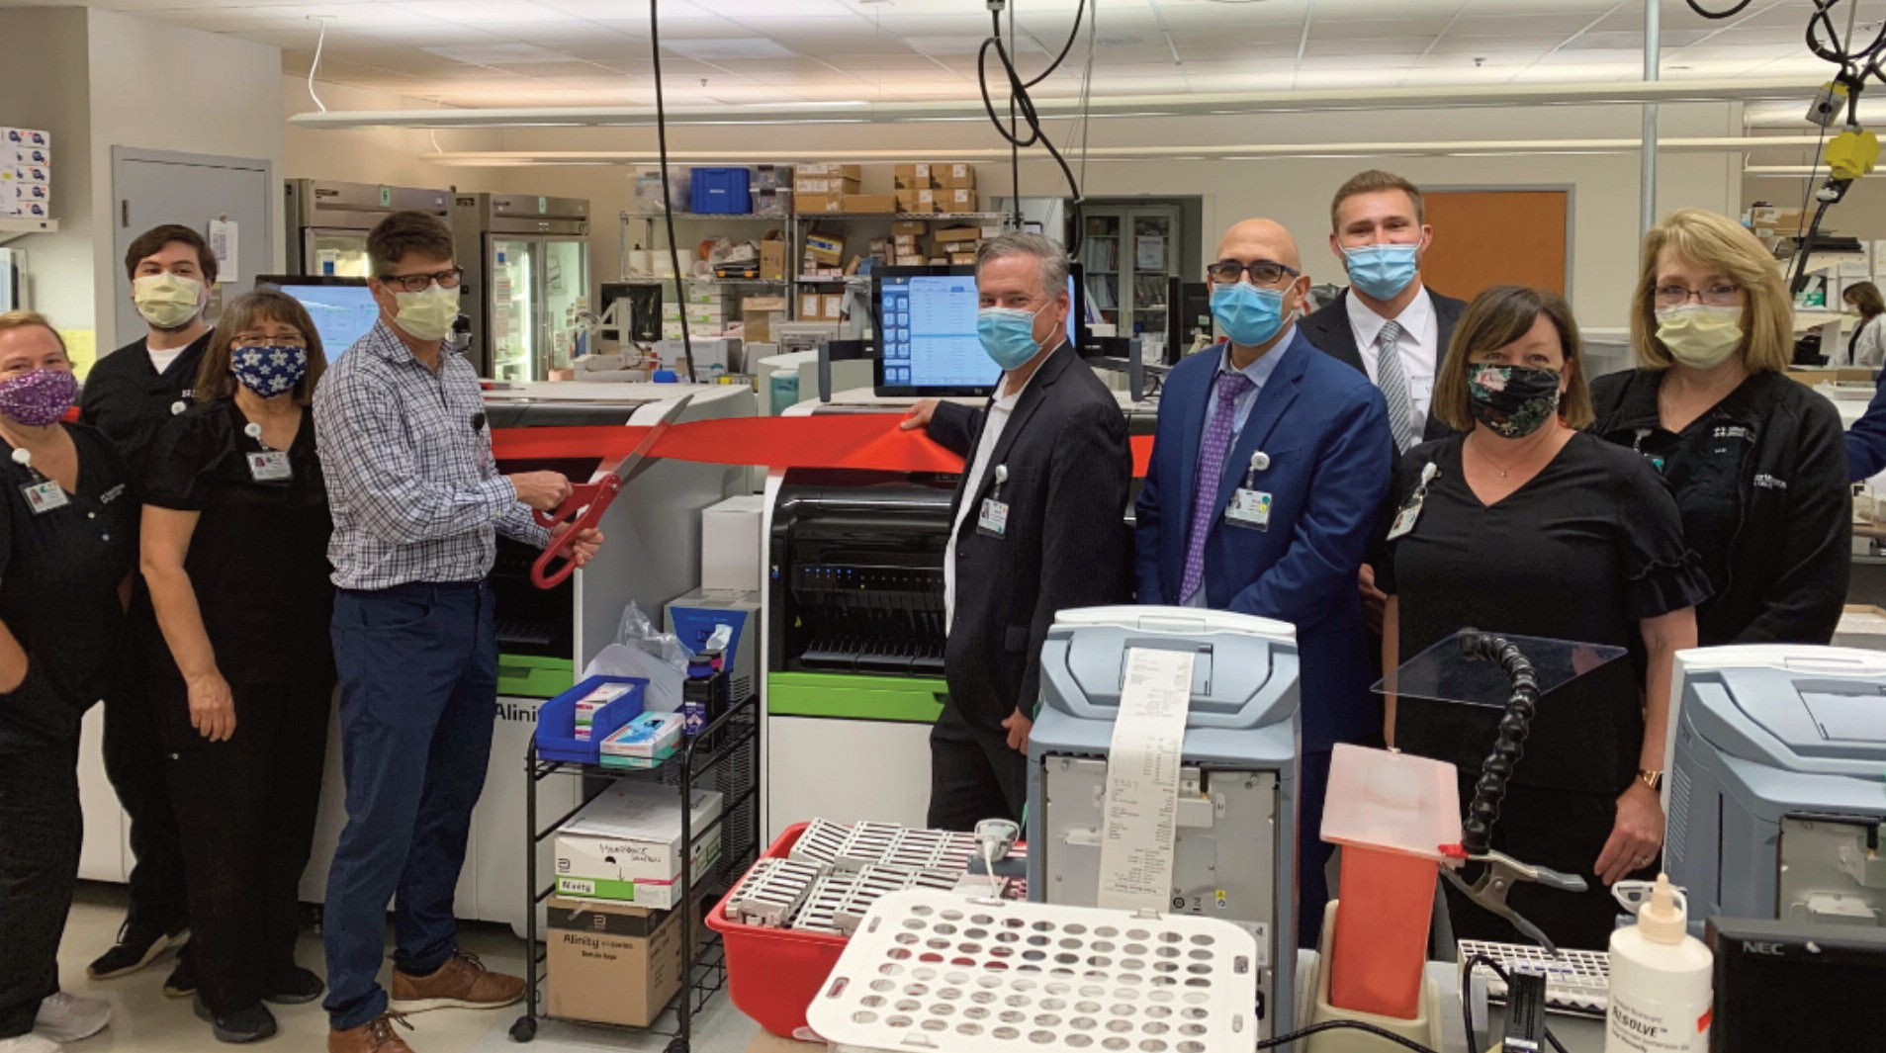

Core Lab to go live. Alinity's innovative technology allows the lab to provide faster, more accurate results while increasing the capacity of the laboratory and driving down costs — which will help improve physician and patient satisfaction and outcomes.

New reference changes, which were previously communicated to Medical Center clinicians and outreach clients, were also implemented as a result of the new technology.

In conjunction with the new automation, the department also commenced a long-planned core laboratory reconstruction project that will overhaul the entire laboratory.



Our testing menu has changed as a result of our new technology as well as other improvements and innovations.

NEW TESTS

Some of our new tests include:

COMING IN

February/March 2022

The following tests, which are currently sent out for analysis,

* Fentanyl
* FSH, LH, Prolactin
* Malaria Antigen Testing
* Extended antibiotic

will be brought in house:

ANALYTE

and Progesterone

*(Hormone Level Testing)*

* Free T3
* H-Pylori (Stool)

DISCONTINUED TESTS

susceptibility for multiple drug resistant organism

* CA15.3

C3

C4

IgA IgG

Ceruloplasmin Haptoglobin Total T4

Total T3

* + Tricyclic (TCAs): TCAs are being dropped by companies and are not available on our new Abbott. There have been significant issues with coverage of the tests for

all drugs in the family as well as cross reactivity.

* + CA27.29

IgM Anti-CCP Anti-TPO

Beta 2 microglobulin

DHEA-S SHBG

Testosterone, Total

BLOOD BANK AND DONOR CENTER MAINTAINS SUPPLY



## The Division of Transfusion Medicine actively supports the clinical mission of Medical Center by ensuring a safe and adequate blood supply. The Blood Donor Center contributes to the blood products transfused to Medical Center patients and has successfully responded to serious nationwide blood shortages in order to maintain

## uninterrupted clinical operations during the COVID-19

## pandemic.

## Our most recent blood drive t in July brought in

## more than 200 donations.