Example Stop Light Report

Rounding Follow-up
November 2021

- Completed! These are opportunities that we answered right away.
  - Training 4 New CLS (1 for Grave yard and 1 for PM shift)
  - Opened 1 CLS evening shift position.
  - Trained and moved 1 CLS to grave yard shift.
  - Completed Training 1 part-time Lab assistant
  - Conducted staff meetings with all shifts.
  - Implemented 2 new refrigerators

- Work in Progress: These are opportunities that we couldn’t answer right away, but are working on.

We can’t do now and here is why: These are requests that we cannot do at this time and the reason why.
More space in the Transfusion Service; need more benches and more storage space

About the Stop Light Report  The Stop Light Report is a way to communicate (post on communication boards) how the ideas/concerns harvested in rounding are addressed.  Green Light items are things that have been addressed and are complete.  Yellow Light items are things in progress.  Red Light items are those issues or ideas that cannot be done with the reason why.  Items are dated when they are posted to the report and dated again when moved to green or red areas of the report. | 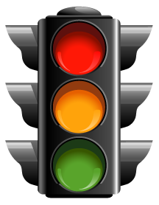  This Photo by Unknown Author is licensed under CC BY-NC

