Example Stop Light Report with Managers and Employees

Rounding Follow-up
March 2022

- Completed! These are opportunities that we answered right away.
- Promoted Core Lab manager from within
- Hired new Pathology manager
- Received and implemented two new refrigerators
- Promoted several CLS I to CLSII
- Promoted few Phlebotomists from CPT I to CPTII
- Based on feedback from our patients extended draw station hours to 4 PM
- Based on feedback from staff purchased new CINTAS lab coats with logo and name
- Based on feedback from staff implemented a temperature monitoring system
- Completed equity adjustment for few staff members
- Ordered few printers and scanners
- Ordered a couple of new chairs

- Work in Progress: These are opportunities that we couldn’t answer right away, but are working on.
- Upgrading REES system
- Implementing new Vision Swift instrument
- Remodeling space in blood bank and Pathology

- Employee culture of safety feedback (meeting to be scheduled)
    - Working on enhancing staff recognition
    - Working on improving staff communication and team work
    - Working on enhancing trust among staff and collaboration

We can’t do now and here is why: These are requests that we cannot do at this time and the reason why.
More space in the Transfusion Service; need more benches and more storage space

About the Stop Light Report  The Stop Light Report is a way to communicate (post on communication boards) how the ideas/concerns harvested in rounding are addressed.  Green Light items are things that have been addressed and are complete.  Yellow Light items are things in progress.  Red Light items are those issues or ideas that cannot be done with the reason why.  Items are dated when they are posted to the report and dated again when moved to green or red areas of the report. | 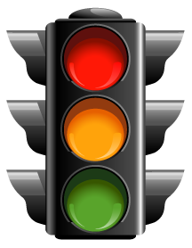  This Photo by Unknown Author is licensed under CC BY-NC

