# You Are Currently Viewing

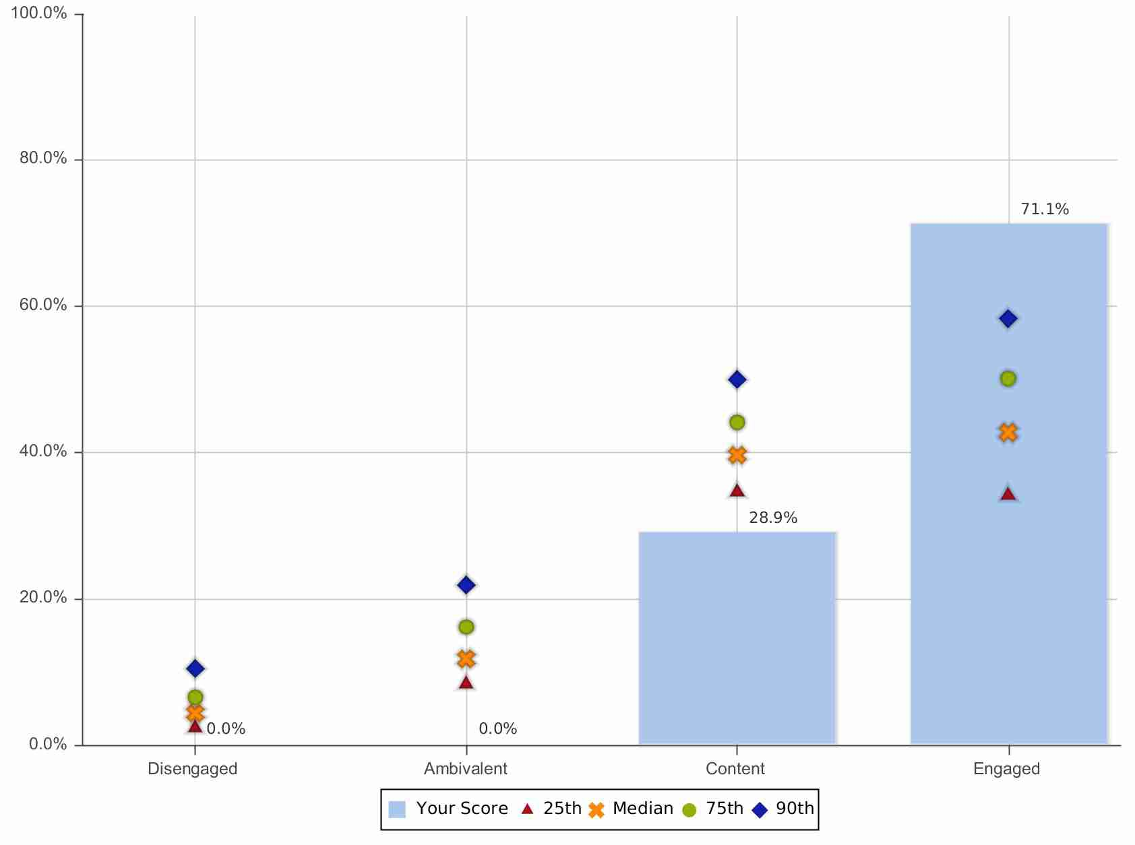

|  |  |  |  |  |  |  |
| --- | --- | --- | --- | --- | --- | --- |
| Engagement Metric | Your Score | Percentile | 25th | Median | 75th | 90th |
| % Engaged | 71.1% | 97 | 34.1% | 42.8% | 50.1% | 58.3% |
| % Disengaged | 0.0% | 1 | 2.3% | 4.3% | 6.5% | 10.4% |
| Engagement Index | 5.68 | 98 | 4.95 | 5.11 | 5.25 | 5.39 |

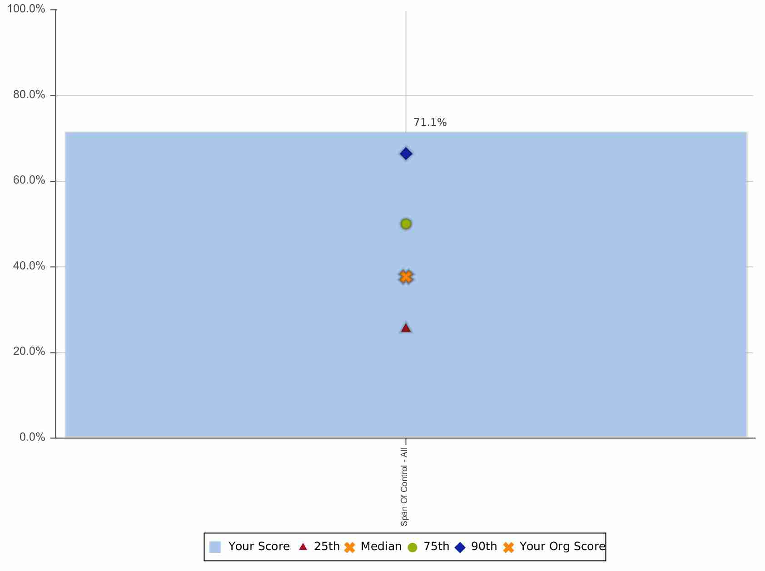

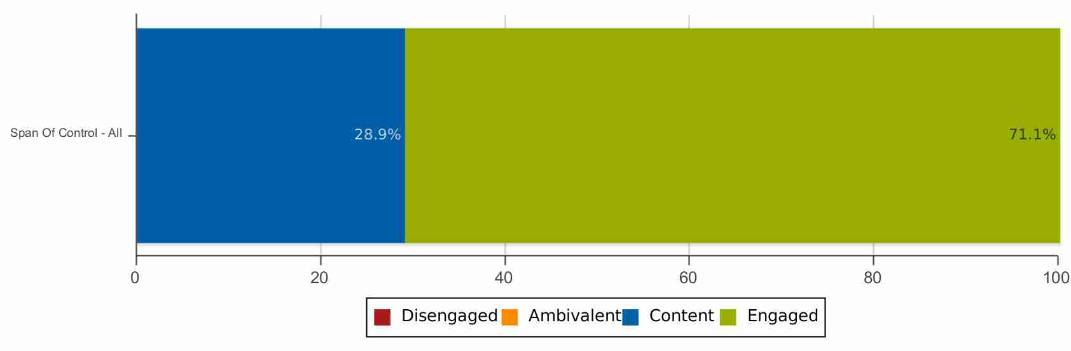

The top driver strengths are the 3-8 questions on which this group is performing the best, factoring in (1) your score compared to the national benchmark, and (2) the relative impact of each driver on engagement.

|  |  |  |  |  |  |  |
| --- | --- | --- | --- | --- | --- | --- |
| Driver | Category | % A/SA | Bench % A/SA | Gap | Stat Sig | Top Impact Driver |
| * My unit/department has enough staff | Employee Support | 71.4% | 41.8% | 29.7% | Y (+) | Y |
| * My organization does a good job of selecting and implementing new technologies to support my work | Employee Support | 92.9% | 63.0% | 29.8% | Y (+) | Y |
| * My manager helps me learn new skills | Manager Effectiveness, Professional Growth | 90.5% | 63.8% | 26.7% | Y (+) | N |

The top driver improvement opportunities are the 3-8 questions on which this group has the greatest opportunity for improvement, factoring in (1) your score compared to the national benchmark, and (2) the relative impact of each driver on engagement.

|  |  |  |  |  |  |  |
| --- | --- | --- | --- | --- | --- | --- |
| Driver | Category | % A/SA | Bench % A/SA | Gap | Stat Sig | Top Impact Driver |
| * My coworkers do a good job | Teamwork | 81.0% | 80.9% | 0.1% | N | N |
| * I have good personal relationships with coworkers in my unit/department | Teamwork | 97.6% | 86.4% | 11.2% | Y (+) | Y |
| I believe in my organization's mission | Mission and Values | 92.9% | 87.7% | 5.2% | N | Y |
| * I know what is required to perform well in my job | Feedback and Recognition | 100.0% | 90.2% | 9.8% | Y (+) | Y |
| * I receive the necessary support from employees in other units/departments to help me succeed in my work | Teamwork | 78.6% | 65.5% | 13.1% | Y (+) | Y |
| * I receive the necessary support from employees in my unit/department to help me succeed in my work | Teamwork | 83.3% | 74.7% | 8.6% | N | N |

|  |  |  |  |
| --- | --- | --- | --- |
| Custom Question | n | % A/SA | % D/SD |
| In our department, we are encouraged to think of ways to be efficient with our resources. | 42 | 88.1% | 0.0% |
| The processes I use to do my work are as efficient as possible. | 42 | 85.7% | 2.4% |
| The message regarding operational efficiency's importance at Cedars-Sinai is communicated well. | 42 | 83.3% | 2.4% |