**Sample New Position Justification**

*August 31, 2021*

To: _____________________, Sr. VP, Ancillary Services

From: _____________________, Laboratory Director

*Re: New Positions-Clinical Lab Scientist I*

*Lab Technician I*

We would like to hire a new CLS I and Lab Technician I entry level to come in at 12 noon (12 noon-8:30 PM) to help with outreach volume arrives in the lab around noon. Also, the bulk of the outreach volume comes in the lab around 2 and 3 PM which is around the change of shift. There could be potential errors in the laboratory due to the increased volume and short staffing. I received multiple emails from staff requesting help during the hours of 12 noon-8:30 PM. We will need about 2 months to recruit and hire new qualified applicants and we have a couple of retirements coming up the beginning of 2022. We also anticipate additional volume from new physician offices to start coming in the 1st Q of 2022. Below you can see the hourly volume for chemistry only without Coagulation, CBC, Urinalysis and other tests. The units of Service in July increased by 10, 602. Below you also find the UOS and productivity numbers. This was also brought up in our most recent Culture of Safety Survey, staff reported that they are stretched thin and burned out due to the increase volume during this timeframe (1200-2030).

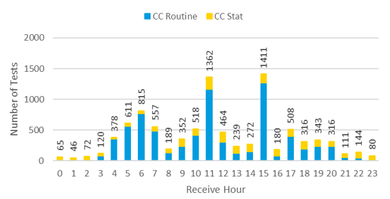

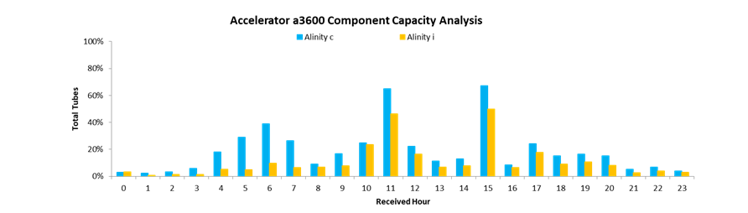

|  |  |  |  |  |  |  |  |
| --- | --- | --- | --- | --- | --- | --- | --- |
| Cost Center | Division | Actual UOS (July 2021) | Budgeted UOS (July 2021) | UOS Difference | % increase | Productivity  8/21/21 | Productivity  YTD |
| 750000 | Phlebotomy-Inpatient | 30,503 | 25,688 | 4,815 | 19% | 135% | 123% |
| 754000 | Blood Bank | 6,077 | 5,407 | 670 | 12% | 113% | 101% |
| 750020 | Microbiology | 11,211 | 10,799 | 412 | 4% | 126% | 118% |
| 750030 | Core Lab | 124,820 | 120,250 | 4,570 | 4% | 101% | 96% |
| 758000 | Pathology | 5,622 | 5,487 | 135 | 2% | 94% | 97% |
| Avg. |  |  |  |  | 8.2% | 114% | 107% |

*Thank you for your consideration and support*

*Sincerely,*

_____________________