SUCCESSION PLANNING IN HEALTHCARE ORGANIZATIONS

Ihab Abumuhor, MS, MLS(ASCP)SBB

California State University, Long Beach

Dr. Daniel Fahey

Human Resources

HCA 510



AUGUST 5, 2018

CSULB, HCA 510 (HUMAN RESOURCES)

Dr. Fahey

**Introduction**

Recently Healthcare organizations became more aware of the need for succession planning and talent development. Succession planning is critical to the success of any organization especially in a rapidly changing healthcare environment. Aging healthcare workers are leaving the profession and are creating huge gaps which need to be filled. The unavailability of schools and training programs are also contributing to the unfilled open positions. For example, in the Clinical Laboratory Science (CLS) field, most of the schools and training programs closed due to budget cuts. There are more CLS student who are waiting to enroll in training programs than there are available training slots. There are also negative perceptions regarding the healthcare sector which leads to the lack of interest in the profession. Healthcare organizations should have initiatives that outline extensive employee recruitment, retention, leadership development, and succession planning programs to increase organizational performance and accountability. Finding and retaining highly qualified healthcare workers in nursing and other professions is critical to the success of any organization. Over the past few years, organizations ignored the recruitment and development of the next generation of leaders and now management feels that they are inadequately prepared for the future (Griffith, 2012).

Succession planning in any organization offers many benefits. First, it offers a climate of stability where the transition occurs more smoothly without any interruptions or gaps in service. Second, succession planning allows for a smooth transition of human capital and leadership. Staff who are being mentored know how to navigate the institution and are aware of all the policies and procedures. With succession planning, especially mentoring and promoting from within, allows the organization to maintain the mission and strategic vision. This will keep the department or division strategic goals aligned with the institution strategic goals. This is usually true when future or potential leaders are groomed with existing leadership still in command. Third, organizations that do not prepare for succession planning will place them at a greater risk. Especially in our current healthcare environment where we are moving towards value-based purchasing where organizations need to become more efficient and cost effective while keeping quality high. We need great leaders to lead the organization into the future. It makes good business sense to promote and groom staff from within as they will be more committed to the organization and be more cost effective. Succession planning need to be applied at all levels of the organization and not just top management or highly paid positions (Fibuch & Van Way, 2012).

**Statement of the Problem**

Historically, healthcare organizations promoted employees into leadership positions without evaluating the leadership potential or without any succession planning, training, or talent development. I was promoted to supervisor and then to a manager without any training or being a part of any succession planning program. A few years ago, Cedars-Sinai Medical Center started enrolling employees with leadership potential in a Talent Development Program with the help of Organizational Development. Prior to my promotion to Associate Director, Cedars-Sinai enrolled me in an 18-months Advisory board program while being mentored by my executive director and vice president. As baby boomers age, they place an increased demand on filling up gaps in the healthcare sector which might deplete the current workforce. Healthcare organizations need a current strategy in place to survive, let alone stay ahead of their competitors. It is the responsibility of the current leaders to remain open and transparent to develop future leaders. Management needs to identify future leadership gaps by creating plans for a small number of positions and prioritize those that have high retirement risk and strategic importance. Both are equally important. Healthcare organizations need to focus on those likely to retire in the next 2 years, as well as focus on the critical and hard to fill positions with special technical talents or those requiring more experience to be successful in the role. Human capital is an important asset and is the reason for driving organizations to the next level and making them successful. Organizations that stand out have great leaders who are engaged and motivated. Succession planning offers a smooth transfer of knowledge and ensures that there are successors in place to fill key positions. Succession planning can be applied throughout the organization. Historically, healthcare employees with exemplary technical skills were promoted into leadership roles. However, technical skill does not equate to leadership potential. Recently I was given a survey to test my leadership potential and identify any gaps that I need to work on to move on to the next level. Without proper leadership development, many of the talented healthcare individuals in their current position will not succeed in their new role (Sibbald, Wathen, & Kothari, 2017).

Succession planning is an organizational challenge that I am currently dealing with. A year ago, when I took over the Division of Transfusion Medicine as the Associate Director, I performed a gap analysis of the entire Division and one of the areas that I found lacking was “Succession Planning”. Identifying potential leaders and working with them on a regular basis to help them achieve their future goals will not only help fill key positions but also enhance the employee engagement scores. Engaging employees builds trust and a culture of respect, especially during times of rapid change and integration. Soliciting feedback from employees helps identify actions we can take as leaders in health care towards meeting our goals. Three main areas of concern were lack of teamwork, low morale, and recognition. Teamwork and recognition are two areas that are crucial to the success of any institution to improve efficiency, reduce costs, and provide high quality care. This leads us to the million-dollar question:

**If Succession planning is so important, why isn’t it happening in many organizations?**

Succession planning is one of the multiple priorities healthcare leaders must plan for. With all the other priorities that healthcare professionals must deal with from short term to long term planning, attending meetings, and keeping up with day to day operations, they find that succession planning to be the last thing on their agenda. Succession planning might be the last item on the agenda but is one of the most urgent needs in our current healthcare environment. Most organizations are moving towards improving efficiency and cutting costs. Leaders find themselves that they must do more with less. However, to deliver high quality care, leadership is essential to maintain an efficient, low cost, and high-quality healthcare (Prestia, Dyess, & Sherman, 2014).

A systematic approach is needed to develop our future healthcare professionals. Succession planning must be a management incentive goal for every healthcare leader. We have the responsibility as leaders to develop qualified candidates and prepare them to accept the new role as they become available. This will allow for a seamless transition without any gaps in service. There are so many approaches to succession planning from a more formal program to a less formal “one-on-one-mentor”. No matter what program healthcare organizations and healthcare leaders choose to utilize, the program must have 5 key components: Identify key positions, identify key potential candidates, develop potential candidates, appoint successors, and commit resources to develop the candidates (Brunero, Kerr, & Jastrzab, 2009).

**Questions to Determine if Succession Planning is necessary:**

* What will happen when you retire?
* Do you have a strong internal pool of interested candidates?
* Are multiple individuals with the same title retiring in the same time frame?
* Are there already strong internal staff members at a junior level?
* Are there enough junior level people to fill the pipeline?
* Does HR need to take measures to target new labor pools?
* Will this role be important in the future?
* For remaining titles, develop customized retention plans for each employee while grooming successors.

**Where do you find value when implementing succession planning?**

Value is in middle management. Based on the Occupational Handbook of the Bureau of Labor Statistics, middle managers are responsible for coordination of medical/health care as well as planning and directing. Their roles as middle managers could serve an entire organization or in a specialty clinic. Overall, their goals are to improve the quality in health care delivered, as well as keep the department up to date with rules and regulations for ever changing health care compliance issues. In addition, their responsibilities also include supervising other assistant administrative staff and management of the finance department. Based on data, many middle managers do not feel the appreciation and recognition deserved for the work that they do. Perhaps many scholars believe that organizations can still function without the presence of these intermediate positions, so the question lies in whether or not they can even serve as potential future leaders in succession planning, as improper middle manager development can lead to overworked employers which could increase costs for any organization in terms of higher turnover rates. Middle managers have the knowledge in the actual work-flow required to make both quantitative and qualitative changes to their respective health care systems, as well as truly understand the complex detail necessary to bridge information between senior executives, frontline employees, and patients, thereby allowing them to provide a wider base of problem solving as needed depending on the situation at hand. Skills that middle managers possess include being detail oriented, ability to be analytical and adaptable while communicating effectively, possessing interpersonal skills, problem solving innovatively, as well as a long list of technical skills (Belasen & Belasen, 2016).

The position of a middle manager, however, can have its drawbacks, as the position may not have as much decision-making power, yet have to handle the problems of upper management and lower level employees which in turn can cause middle managers to feel more depression and anxiety. Middle managers often feel pressure to work more to improve their current performance as well as complete any unfinished tasks from other workers, thereby becoming “hyper effective.” My position is considered “middle management” and I constantly feel the pressure from upper management to keep my employees motivated and engaged. The constant pressure of completing the projects on time, day-to-day operations, deadlines, performance evaluations, staff shortages, keeping productivity high, and keeping expenses within or below budget is tremendous. Initially, being hyper effective can make middle managers over deliver expectations, but these continued behaviors can cause a great loss of personal time and an increase in feeling unappreciated or powerlessness. By increasing one’s responsibilities that lead to burnout, this can negatively affect succession planning for the future. Currently, hospital executives are not focusing enough on planning for the future in terms of developing potential leaders to take their place in order to maintain a successful business and competitive advantage (Belasen & Belasen, 2016).

**Creative and effective succession planning**

Among administrative roles in the healthcare industry, particularly in nursing, the transition between retiring high-level individuals and future potential candidates requires succession planning. Over the years, the current population has been living longer with more complicated diseases, thereby increasing the need for continued qualified nursing care. For all current nurse leaders, there should a focus and attention brought to making sure that there continues to be highly qualified and knowledgeable nurses in the healthcare system. It is necessary to utilize succession planning so that potential leaders can begin to engage and be mentored by retiring management to learn important things such as how to effectively and efficiently lead a group of diverse stakeholders in addition to the skills needed given the resources. Without a proper transition and leadership training, there could be costly and negative effects to any organization long term. Per Beglinger, the steps necessary for effective succession planning is to first engage the director currently in the plan and make it clear to him/her that recruitment and mentoring a potential successor by no means would be entitled to take over in a specific period (refer to figure 1). The director would assume the role as the mentor upon his/her discretion, regardless if the transition took a year or even longer. Second, the administrative team will need to make changes to support the main goal which is succession planning. Once a plan is communicated to an organization, a highly qualified candidate should be identified and a clearly defined plan of action and transitioning responsibility should be put into place so that there is no confusion amongst staff, physicians, and directors involved based on a timeline. One should also consider that indeed the new potential leader may do things slightly different, and opportunities should be granted for this new individual to gain experience and see how his/her decisions affect the organization (Beglinger, 2013).

**Figure 1: Steps in Succession Planning (EDUCBA, 2017)**

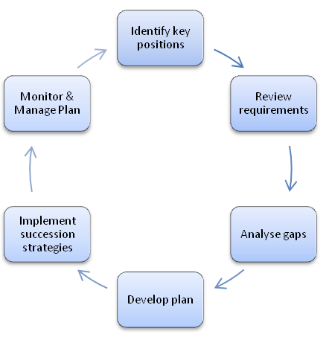

**Strategies and tactics for effective succession planning**

**Weighing Positions**

Using position criticality in addition to retirement risk offers a more targeted approach to succession planning than focusing more generally on retiring leaders. However, the process of identifying critical positions can be onerous and sometimes inaccurate. Start a conversation in the department on the philosophy of succession planning about the reasons for succession planning and how the plan will be used. Planning for coverage during scheduled time off or a planned absence is different than planning for a permanent replacement, and both scenarios require a time investment.  The tool in figure 3 will help identify roles most vulnerable to retirements. If there is information on position criticality, one should prioritize individuals in critical positions at risk for retirement. Identifying key positions that may be unique to the leadership structure and lead workers should be considered part of the succession plan. Also identify those who can step into leadership roles immediately and those who can be successful with additional development (Farthing, 2013)

**Figure 2: Weighing Position Critically and Retirement Risk (Advisory Board, 2016)**

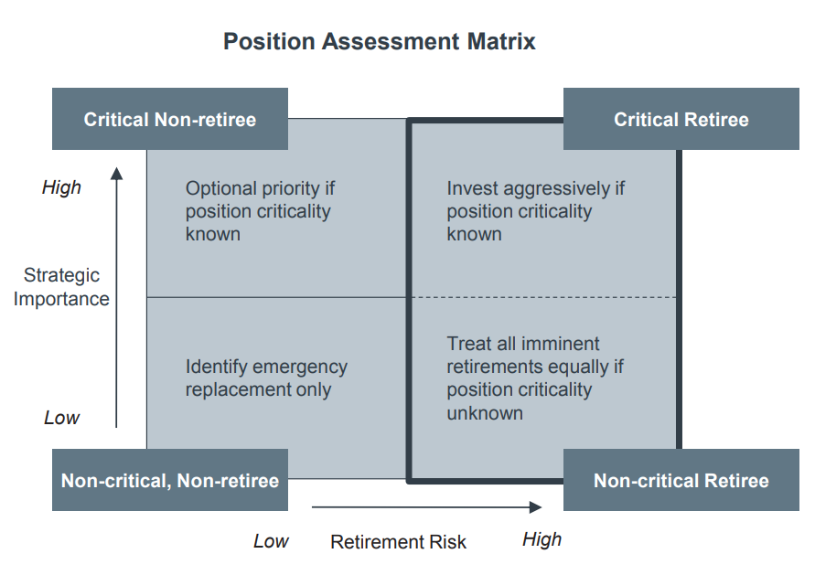

**Succession Planning Intervention Evaluation**

How do we improve our chances of identifying the right people and boost the critical pipeline? First, calculate the average age of employees by job title or management level. Second, sort titles in descending order of age and pinpoint the top 10-15 titles with oldest employees. Third, for individuals with these titles, directly survey current jobholders or interview supervisors to determine what percentage of these employees plan to retire within the next two years. Fourth, those planning to retire in the next two years, consider the following factors to determine if formal succession planning is necessary for the position: Volume of Potential Departures, are multiple individuals holding the same title planning to retire within a similar timeframe? Strength of existing pipelines: are there already strong internal (junior-level roles, cross-trained staff from other departments) or external pipelines in place for this role? If so, will these pipelines, at current course and speed, produce enough candidates to meet the need created by retirements? Does HR need to take measures to increase existing pipelines or target new labor pools?

**Employee Profiles Commonly Mistaken for High Potential**

What this means is that we must discriminate between the high performers who might be suited to deeper functional roles and high potential employees who can build on their high performance and step into higher and broader general management roles. Confusing the two might lead to promoting the wrong people, with potentially catastrophic outcomes for the individual and the healthcare organization. Therefore, it is vital to objectively measure potential for future growth and to have a clear understanding of what that means across the business. It can be equally challenging to identify leaders with high potential. There are at least three common misunderstandings of potential, each of which is described in the table below (Refer to table 1) (Newhall, 2015).

**Table 1: Employee profiles commonly mistaken with high potential (Advisory Board, 2016)**

|  |  |  |
| --- | --- | --- |
| **“Mini-Me”** | **“Old Faithful”** | **“Ivy League”** |
| * Younger versions of current manager. * May not possess leadership qualities needed in the future. * More problematic if current incumbent is underperforming. * Likely to hinder diversity efforts | Long-time employee; loyal to institution and to manager.  Despite deep institutional knowledge, may never have wherewithal to perform at a higher level, even with additional development. | * Highly intelligent; may hold several degrees and accreditations. * Performs well in academia but may not possess business nor political savvy required at higher levels. |

**Identify Top Talent**

After selecting a limited number of positions warranting succession plans, organizational leaders need to identify a limited number of individuals with the potential to fill these roles. However, organizational leaders often select high-potential talent based on a direct supervisor’s opinion alone and do not apply consistent definitions of performance and potential. As a result, organizational leaders frequently select the wrong people or include too many leaders in the succession pool. Organizations should use two selections to identify a small and manageable set of high-potential individuals comprising of approximately 5% to 10% of all managers. The first selection identifies high performing staff using a common definition of potential, with the goal of narrowing the pool of managers to the top 10% to 20%. The second selection includes a leadership discussion to calibrate assessments and make the final selection of candidates. There are two options for the first wave of selection. The first option is using performance evaluation ratings. If an organization has an accurate performance evaluation process, one can likely narrow the talent pool to the top quartile of performance based on performance reviews alone. If organizations do not want to rely solely on performance evaluation scores, one can use Potential Diagnostic tools such as Korn Ferry. This tool can identify high potential employees and can be used independently of performance evaluations (Advisory Board, 2016).

**Figure 3: Identifying final pool of potential successors (Advisory Board, 2016)**

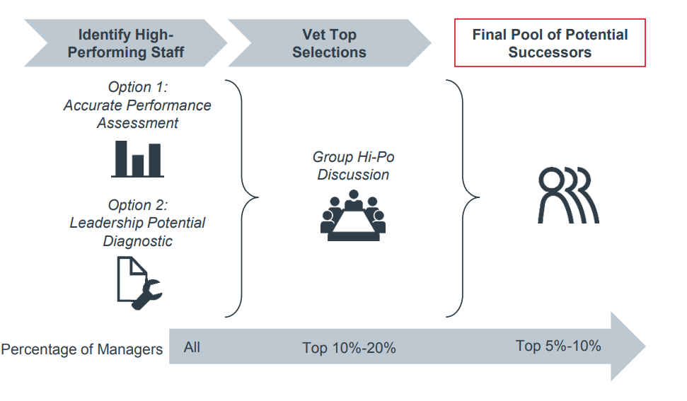

**Identify Leadership Potential**

Not every employee or mid-level manager possesses leadership potential. Some organizations utilize Leadership Potential Diagnostic which helps managers identify high-potential employees by evaluating direct reports against a standardized set of behaviors believed to demonstrate high leadership potential (Refer to figure 4). A high-potential employee has the following attributes: talent, ambition, and engagement to rise and succeed in more senior, critical positions within the organization. Leaders must have all three attributes. The diagnostic tool listed below helps identify the fraction of employees in the top quartile of performance that are truly high potential. The tool needed to be distributed to leaders evaluate their direct reports who are potential succession candidates. First, leaders need to narrow the pool of direct reports to top quartile. This can be accomplished through performance evaluations or leadership discretion. Second, individual managers need to complete the diagnostic tool for everyone within this top quartile. Once the questionnaire is completed, the manager who completed each diagnostic should calculate the number of “yes” responses for each question to assess the leadership potential of the employee. Any individuals scoring four “yes” responses or more in all three categories (Talent, Ambition and engagement) should be included in the small set of high-potential individuals to be considered in the Group Hi-Po Discussion. (Bernard, 2014).

**Develop the high Potential employees**

High-performing employees are encouraged to develop their full potential. There are several options that can be taken to develop high potential employees. The first option for developing high-potential staff is giving managers a tool outlining commonly offered development opportunities alongside the specific competencies addressed by each. The tool includes the pros, cons, and critical success factors for each opportunity (Refer to table 2). The second option is to identify specific work experiences high potential leaders should have prior to advancement. This can be done by interviewing senior executives in critical positions to identify the experiences that best prepared them for their current role and then creating a model of experiences required for success in a career path. Direct supervisors can use these proven, experience-based models to ensure that development efforts for high potential incorporate the work experiences needed to succeed in targeted career tracks. Refer to table 2 to find out the differences between mentoring and shadowing (Advisory Board, 2016).

**Figure 4: Leadership Diagnostic Tool (Advisory Board, 2016)**

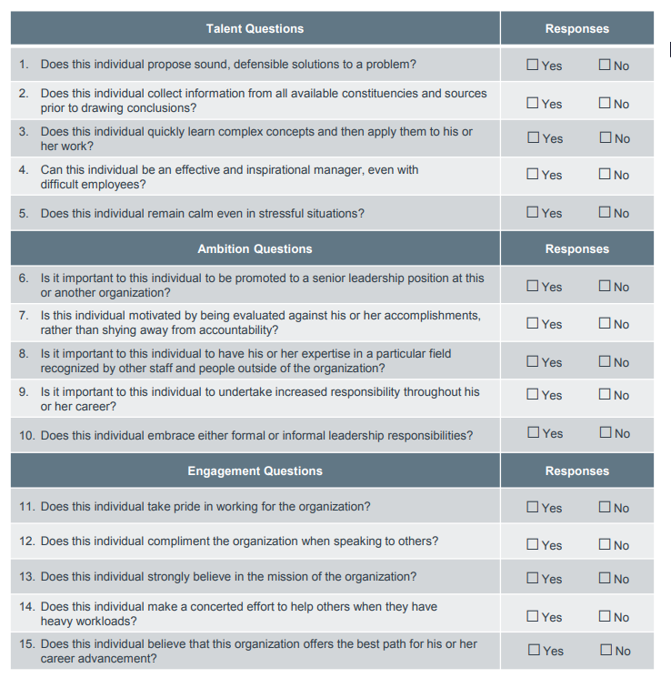

**Create a personalized onboarding plan**

Executives often assume internal successors will be ready to hit the ground running in their next-level roles. All too often, organizations give newly promoted internal successors far less support than they would give to an external hire. To reap full benefits from investing in succession candidates, you must be ready to provide significant support to successors in their first few months in their new role. At my current job we meet with the employee regularly and we have training and competency programs to ensure the employee is on track. We round with the employee monthly, then we evaluate at 3 months and 5 months. We are also required to complete a performance appraisal for new employees at 6 months (180 days) but they do not get a merit increase. This is a way for management to formally document and discuss with the employee, strengths/weaknesses, accomplishments, and any help needed (HRZone, 2013).

**Table 2: Mentoring Vs. Shadowing (Advisory Board, 2016)**

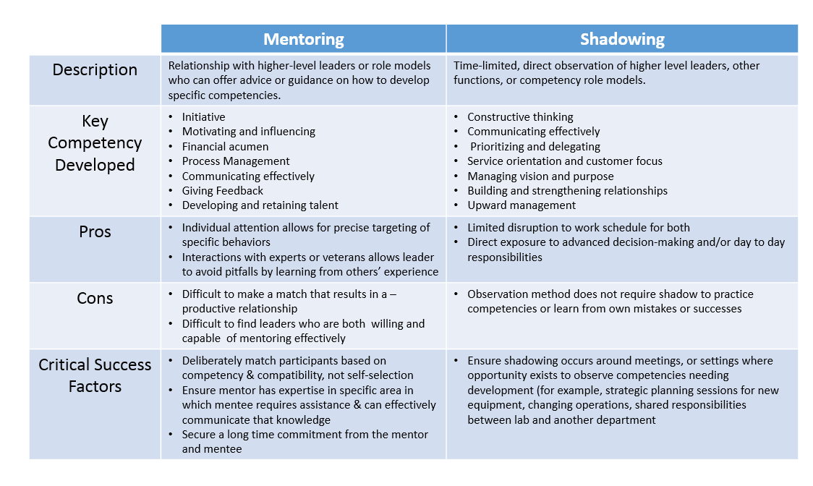

**Figure 5: Sample onboarding plan (HRZone, 2013)**

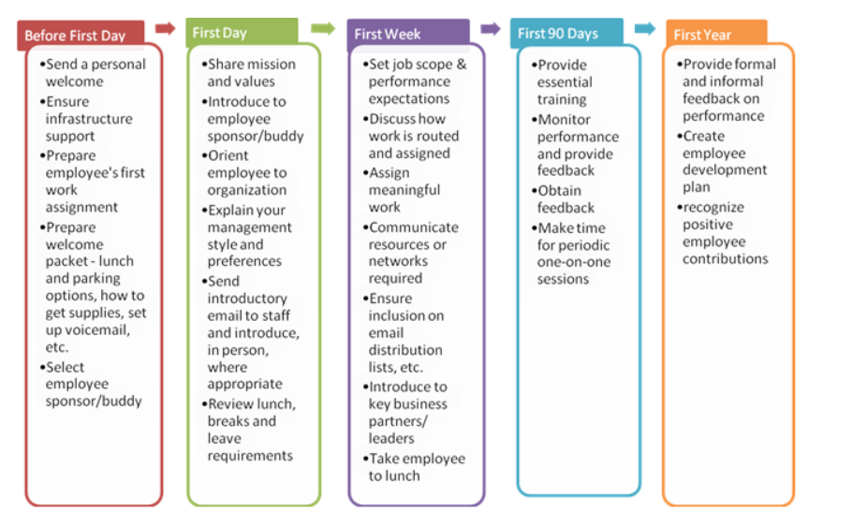

https://www.hrzone.com/talent/retention/a-recipe-for-successful-onboarding-and-a-handy-onboarding-checklist

**Conclusion**

Based on the study conducted by the Aging Workforce Survey, approximately 55% of the participants are planning to enter retirement during 2011 and 2020, majority of whom are nurse managers. In situations like these, it is critical to utilize formal succession planning to ensure that the vacant positions are filled with skilled, knowledgeable, and qualified candidates. The challenge not only lies in recognizing the nurses available to fill these open leadership positions, but also requires the motivation needed for one to want the position as well. Key components of succession planning include identification, training, and mentoring a qualified potential candidate to take over a leadership role. The importance of this business strategy is to continue proper leadership in areas of quality care, management of business finances, and overall workflow of an organization while considering missions and goals. In the case of nurses this is especially necessary due to constant nursing shortages and the demand for leadership roles within this field. By having a succession plan in place will prevent any operational disruption or other organizational duties in case of leadership retirement. Succession planning does not just include having a qualified candidate available for replacement, but it includes professional development, performance assessments, mentorship, and a discussion of aligning the healthcare group’s goals. Another important reason for the importance of succession planning is to assist in sustaining the vision of any organization or health care group. It allows members to become involved and engaged with meetings and mentorship programs to encourage leadership at all levels of an organization (Sverdlik, 2012).

Succession planning plays a major role in financial performance for several reasons. First, organizations that plan for succession planning are better prepared for changes in executive positions. Second, succession planning lessens the disruption that is caused by searching for replacements internally and externally. Third, investing internally in human capital puts the company strategically in a much better position and provides a competitive advantage. Fourth, grooming leaders internally to take on vacant positions decreases the cost of recruitment and replacement. Fifth, succession planning results in continuity of leadership especially in a highly competitive market (Patidar, Gupta, Azbik, & Weech-Maldonado, 2016).

Finally, due to the changes and dynamics of healthcare, succession planning has been used strategically to meet the needs as well as retain knowledge and experience of a growing organization. Succession planning is an integral part of retention of competent staff, mentoring programs, recruitment of qualified workers, as well as allow for effective development of plans to reach hospital goals. This business strategy is imperative to retain the knowledge base within the organization itself and prevent shortages in medical providers. A risk of not identifying these qualified candidates early on is that there may be instances when these knowledgeable staff are needed the most and are unavailable. Leaders must recognize that strategic planning is a critical component of succession planning. Most succession plans in health care recommend planning, identifying and clearly stating future needs and goals, as well as recognizing qualified candidates and potential leaders. It is important to also create a candidate development plan as well as an evaluation procedure to follow up on performance expectations. Leaders must start early in identifying skills and the knowledge base needed, identifying positions, recognizing potential of qualified candidates, mentoring and coaching, proper allocation of resources, and evaluations. Leaders must understand that succession planning, especially in our current healthcare environment, is critical to stay competitive and provide high quality care at the lowest cost. We all need to understand that human capital is the most valuable asset we have and we need to recognize, develop, and promote top talent by keeping them engaged and compensate them financially. Institutions that fail to invest in succession planning will suffer financially. On the hand, institutions that start succession early will have a better competitive advantage and will have the resources to accomplish their strategic mission and vision.

**References**

Beglinger, J. (2013). Designing Tomorrow: Creative and Effective Succession Planning. *Journal of Nursing Administration, 43*(10), 495.

Belasen, A., & Belasen, A. R. (2016). Value in the middle: cultivating middle managers in healthcare organizations. *Journal of Management Development, 35*(9), 1149-1162. doi:10.1108/JMD-12-2015-0173

Bernard, N. (2014). Who's Next? Developing High Potential Nurse Leaders for Nurse Executive Roles. *Nurse Leader, 12*(5), 56-61. doi:10.1016/j.mnl.2014.01.014

Brunero, S., Kerr, S., & Jastrzab, G. (2009). The development and evaluation of a succession planning programme in nursing, in Australia. *Journal of Nursing Management, 17*(5), 576-583. doi:10.1111/j.1365-2834.2009.00990.x

Farthing, K. (2013). Succession Planning: The Right People in the Right Positions at the Right Time. In (Vol. 48, pp. 175-176).

Fibuch, E., & Van Way, C. W. (2012). Succession planning in health care organizations. *Physician executive, 38*(5), 44.

Griffith, M. B. (2012). Effective succession planning in nursing: a review of the literature. *Journal of Nursing Management, 20*(7), 900-911. doi:10.1111/j.1365-2834.2012.01418.x

Newhall, S. (2015). Aligning the talent development and succession planning processes: don’t allow critical leadership talent to fall by the wayside. *Development and Learning in Organizations: An International Journal, 29*(5), 3-6. doi:10.1108/DLO-04-2015-0043

Patidar, N., Gupta, S., Azbik, G., & Weech-Maldonado, R. (2016). Succession Planning and Financial Performance: Does Competition Matter? *J. Healthc. Manag., 61*(3), 215-227. doi:10.1097/00115514-201605000-00009

Prestia, A., Dyess, S., & Sherman, R. (2014). Planting seeds of succession. *Nursing Management, 45*(3), 30. doi:10.1097/01.NUMA.0000443941.68503.09

Sibbald, S., Wathen, C., & Kothari, A. (2017). Managing Knowledge in Transitions: Experiences of Health Care Leaders in Succession Planning. *The Health Care Manager, 36*(3), 231. doi:10.1097/HCM.0000000000000167

Sverdlik, B. (2012). Who Will Be Our Nursing Leaders in the Future? The Role of Succession Planning. *Journal of Nursing Administration, 42*(7/8), 383. doi:10.1097/NNA.0b013e318261938b

Advisory Board (2016). Succession Management Implementation Guide. Retrieved from: https://www.advisory.com/-/media/Advisory-com/Research/HRIC/Resources/2016/Succession-Management-Toolkit/31731_HRAC_Succession_Management_Toolkit.pdf

HRzone (2013). A recipe for successful onboarding - and a handy onboarding checklist. Retrieved from: https://www.hrzone.com/talent/retention/a-recipe-for-successful-onboarding-and-a-handy-onboarding-checklist.

EDUCBA (2017). 6 Important Ways to do Succession Planning Strategy (Guide). Retrieved form: https://www.educba.com/succession-planning-strategy/